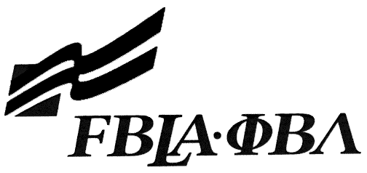 FBLA Statement of Assurance

State Event Entry Form
This form must be completed (TYPED). Please do not submit handwritten forms.
Check one: Computer Game & Simulation Programming E-business
Coding and Programming Public Service Announcement
Digital Video Production Website Design
Electronic Career Portfolio
Provide the complete URL. These events will be judged online. Make sure the URL link is valid through the National Leadership Conference.
State:
School:
Website URL Address: (where appropriate)
Member(s) Name:
Local Chapter Contact
Name:
Daytime/Cell Number:
Home E-mail:

I/We, the undersigned, attest that the design, creation, and implementation of the event are the original work of the above chapter member(s). I/we agree that this event may be linked, promoted, and used in any way by the national FBLA-PBL, Inc. for purposes of promoting the association. (Typed name is accepted for signature)
Name of Team Member |  | Adviser’s Name
Name of Team Member |  | Name of Team Member
Complete this Document Section for the Above Events (replaces Readme file):
Software Used:
Source of Information:
Copyright Notations
Instructions for Running Project:
Template(s) Used (source)

